Decision Tree
Decision tree is a kind of Supervised Learning. We choose decision tree as one of our model to train and test our movie reviews because our movie reviews are already turned to 0 and 1 values.
- Data
The data which decision tree train and test has ten features. Each feature means a word package. There are two values of each word package, zero and one. One means that the word of this package exists in the movie review. Zero means that the word of the package does not exist in the movie review.
- Information Gain
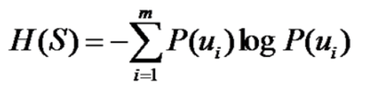
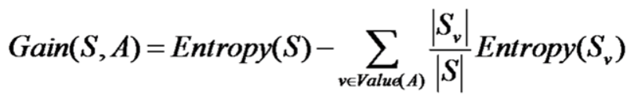
We calculate the information gain of every feature. Choose the max one as our first tree node. Then the value decides which node to go next.
- Split by values
After we get the feature with max information gain, we split the data into two parts by the value zero and one. Calculate each information gain of these two parts. Then we get max information features based on these two parts, and these two feature are next layer of the root node.
- Recursive process
We recursively do 2 and 3 steps, then a tree can be built. And the tree must look like a binary tree because the values are all binary.
- ZeroR
At last, the information gain may be zero, which means the values are all ones or zeros. Then we need to use zeroR to check which value of label has a larger number. And the value is the prediction value of the leaf node.
- Evaluation and improvement
The accuracy is shown below:
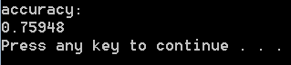
It seems not so good. I think the reason is that we use the word package which is lost some information. To improve this, I think we can use specific words in stead of the word packages. For example, use 200 negative words and 200 positive words as the features.

